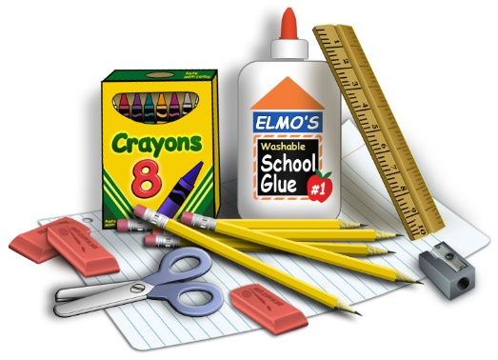

3rd Grade Supply List

**The following supplies will be used daily and need to last all year. Please label with first and last name.**

* over the ear headphones- no earbuds or Bluetooth
* supply pouch (9x13)
* clipboard

**The following supplies will be shared within the classroom community. Please DO NOT label.**

* 6 composition notebooks, wide ruled
* 5 solid color folders with 2 pockets (black, blue, green, yellow, and red)
* 1 box of 24 #2 pencils
* 1 box of Crayola crayons (24 count)
* 2 packs of BLACK EXPO markers
* 2 jumbo glue sticks (Elmer’s)
* Boys: tissues
* Girls: paper towels

**Wish List:**

* Ziploc bags, all sizes
* Disinfectant wipes
* Hand Sanitizer
* Liquid hand soap